Practical - 12
WEB DEVELOPMENT FRAMEWORKS (ITUE203)
SEMESTER: 3RD, 2026-27
ID: 25DCE110

Practical Title: Event Management CRUD with Poster Upload and File Validation

Develop event management functionality for admin users. Admin can add, view, update, delete, and upload event posters with file type and file size validation

Theory

Answers to key questions
1. Are add, update, and delete functionalities implemented correctly?
Yes. Admin users can add new events, update existing event details, and delete events using PHP and MySQLi.
2. Is the UI linked with the database correctly?
Yes. PHP retrieves event records from MySQL and displays them on the event management page.
3. Are poster uploads validated for type and size?
Yes. The server checks the uploaded file's MIME type and size before accepting it.
4. Are success and failure messages displayed?
Yes. The system displays messages when an event is successfully saved, updated, deleted, or when an operation fails.

Implementation/ Output/Result
Tags:
Demo code:
CREATE DATABASE p12_demo;
USE p12_demo;

CREATE TABLE events (
id INT AUTO_INCREMENT PRIMARY KEY,
title VARCHAR(100),
event_date DATE,
poster VARCHAR(255)
);

<?php
$conn = new mysqli("localhost", "root", "", "p12_demo");

if ($conn->connect_error) {
die("Database connection failed");
}

$message = "";

if ($_SERVER["REQUEST_METHOD"] === "POST") {
$title = trim($_POST["title"] ?? "");
$date = $_POST["event_date"] ?? "";
$poster = "";

if ($title === "" || !preg_match('/^\d{4}-\d{2}-\d{2}$/', $date)) {
$message = "Enter valid event details";
} elseif (
!isset($_FILES["poster"]) ||
$_FILES["poster"]["error"] !== UPLOAD_ERR_OK
) {
$message = "Please select a poster";
} elseif ($_FILES["poster"]["size"] > 2 * 1024 * 1024) {
$message = "Poster must be under 2 MB";
} else {
$tmp = $_FILES["poster"]["tmp_name"];
$mime = (new finfo(FILEINFO_MIME_TYPE))->file($tmp);
$types = ["image/jpeg" => "jpg", "image/png" => "png"];

if (!isset($types[$mime]) || getimagesize($tmp) === false) {
$message = "Only valid JPG and PNG images are allowed";
} else {
$poster = bin2hex(random_bytes(12)) . "." . $types[$mime];
$dir = __DIR__ . "/uploads/";

if (!is_dir($dir)) {
mkdir($dir, 0755, true);
}

if (move_uploaded_file($tmp, $dir . $poster)) {
$stmt = $conn->prepare(
"INSERT INTO events (title,event_date,poster)
VALUES (?,?,?)"
);
$stmt->bind_param("sss", $title, $date, $poster);

if ($stmt->execute()) {
$message = "Event added successfully";
} else {
unlink($dir . $poster);
$message = "Failed to save event";
}
} else {
$message = "Poster upload failed";
}
}
}
}

if (isset($_POST["delete"])) {
$id = (int)$_POST["id"];
$stmt = $conn->prepare("DELETE FROM events WHERE id=?");
$stmt->bind_param("i", $id);
$message = ($stmt->execute() && $stmt->affected_rows > 0)
? "Event deleted successfully"
: "Event not found";
}

$result = $conn->query("SELECT * FROM events ORDER BY id DESC");
?>

<h2>Event Management</h2>
<p><?= htmlspecialchars($message) ?></p>

<form method="post" enctype="multipart/form-data">
<input name="title" placeholder="Event title" required>
<input type="date" name="event_date" required>
<input type="file" name="poster" accept=".jpg,.jpeg,.png" required>
<button type="submit">Add Event</button>
</form>

<h3>Events</h3>
<?php while ($event = $result->fetch_assoc()): ?>
<div style="border:1px solid #aaa;padding:10px;margin:10px">
<h3><?= htmlspecialchars($event["title"]) ?></h3>
<p><?= htmlspecialchars($event["event_date"]) ?></p>

<img src="uploads/<?= rawurlencode($event["poster"]) ?>"
alt="Event poster" width="150">

<form method="post"
onsubmit="return confirm('Delete this event?')">
<input type="hidden" name="id" value="<?= (int)$event["id"] ?>">
<button name="delete">Delete</button>
</form>
</div>
<?php endwhile; ?>
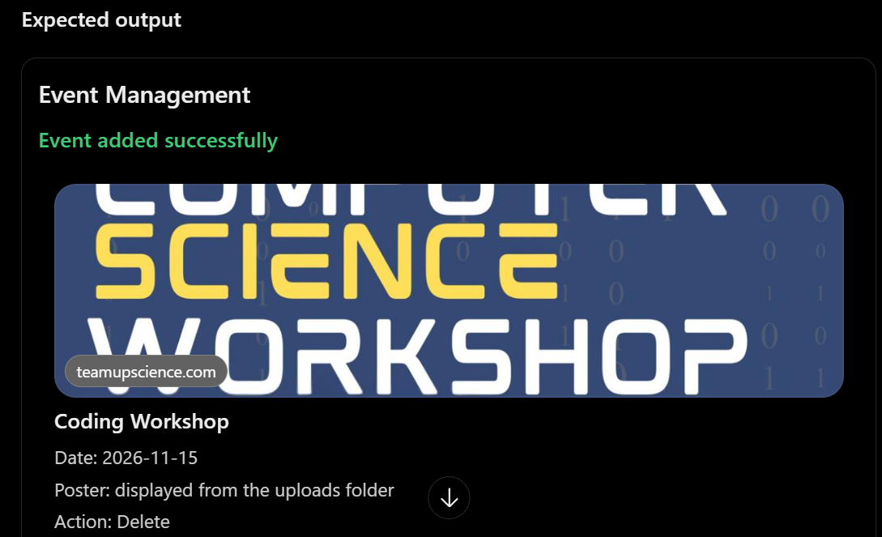

- Created an event management interface for administrators.
- Connected PHP to MySQL using MySQLi.
- Implemented event insertion, viewing, updating, and deletion.
- Added poster upload functionality.
- Validated poster file type and maximum size on the server.
- Generated unique filenames for uploaded posters.
- Displayed success and error messages.
- Restricted event management to authorized admin users.

GitHub Repository Link:
https://github.com/kanan2007s-sys/Web-development-/tree/main

Learning Outcomes:

Learned to develop an event management CRUD module with validated file uploads and database connectivity.

Faculty Remarks:

